**Workforce Data Analysis Report: Faculty of Engineering Attrition Trends**

**Prepared for:** Jane Shaw, HR Business Partner  
**Prepared by:** Omkar Masurekar  
**Date:** May 19, 2025

Table of Contents

Executive Summary

1. Attrition Trends & Patterns
   1. Overall Termination Metrics
   2. Key Trends
2. Predictive Risk Analysis (XGBoost Model)
   1. Model Performance
   2. High Risk Groups
   3. Job Titles at Highest Risk
3. Survey & Performance Insights
   1. Risk Distribution by Performance & Engagement
   2. Termination Drivers
4. Recommendations
   1. Immediate Actions
   2. Long-Term Strategies
5. Conclusion

## 

## **Executive Summary**

This report synthesizes insights from the Power BI dashboard and predictive modelling to analyse attrition trends in the Faculty of Engineering and benchmark against other faculties. Key findings include:

* **Attrition Rate:** 51.66% in Engineering, marginally higher than Arts (51.78%) and Medicine (50.50%).
* **Voluntary Departures** dominate (~52.89%), with early-tenure (<1yr) most affected.
* **Predictive Model Accuracy:** 97.2%, identifying 11 high-risk employees in Engineering.
* **Risk Drivers:** Low performance ratings (Low/Medium) and SEW (Average of Satisfaction Engagement and Work Life Balance) scores correlate with higher attrition.

## **Attrition Trends & Patterns**

* + **Overall Termination Metrics**

|  |  |
| --- | --- |
| **Metric** | **Value** |
| Total Employees | 3,000 |
| Active Staff | 1,467 |
| Terminated Staff | 1,533 |
| Attrition Rate | 51.10% |

* + **Key Trends**

**By Faculty:**

* Engineering and Arts show nearly identical attrition rates (~51.6%), but **Engineering has 52.89% involuntary departures** (highest among faculties).
* Medicine retains more staff (49.50% active).
* A gender disparity was noted, with female staff having a slightly higher voluntary termination rate.

**By Termination Category:**

* Voluntary departures peaked in 2023 (289 cases)
* Involuntary departures are highest in Engineering (52.89%) then in other faculty.

*(See***Terminated Staff Analysis***tab in Power BI for interactive charts.)*

## **Predictive Risk Analysis (XGBoost Model)**

**XGBoost predicts attrition risk** by analysing patterns in historical data and assigning probability scores to employees.

* + **Model Performance**

|  |  |
| --- | --- |
| **Metric** | **Value** |
| Model Accuracy | 97.20% |
| % Predicted At Risk | 2.80% |
| High-Risk Employees | 41 |

*The XGBoost model identified these key drivers of attrition (in order of importance)*

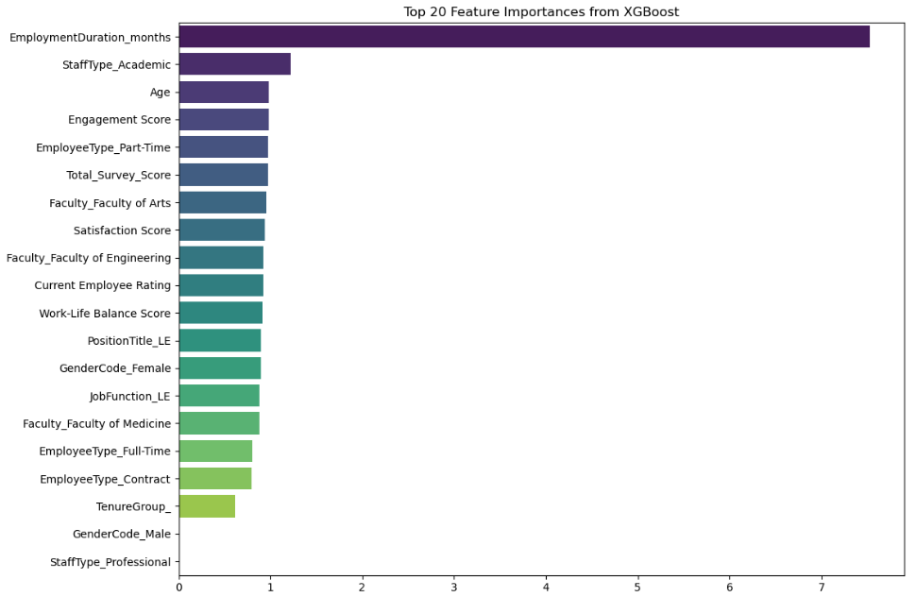

* + **High Risk Groups**
* **Engineering: 11 high-risk employees**, primarily 1-3yrs tenure staff with medium performance groups.
* **Medicine: 26 high-risk employees**, often medium performers with medium or low total score groups.
* **Arts: Only 4 high-risk cases**, but medium performers with low and medium engagement groups.
  + **Job Titles at Highest Risk for Engineering**
* Manager (3 predicted exits)
* Research Fellow (1)
* Assistant Lecturer (1)
* Professor(1)
* Senior Officer(1)
* Accountant(1)
* Associate Professor(1)
* Senior Research Fellow(1)

*(See***Predict Terminations for Active Staff***tab for probability scores and employee details.)*

## **Survey & Performance Insights**

* + **Risk Distribution by Performance & Engagement**
* **Engineering:** Employees with low performance + medium SEW scores face **59.34% attrition risk**—the highest of any group.
* **Arts:** High performers with low SEW show 58.18% risk, indicating engagement drives exits.
* **Medicine:** Attrition is evenly distributed, with medium performers + low SEW as the largest at-risk group.
  + **Termination Drivers**
* Primary Drivers: Low tenure (<1yr) and low engagement.
* Secondary Factors: Academic staff (vs. professional) are slightly more likely to leave.

*(See***Survey Score Analysis***tab for faculty-wise breakdowns.)*

## **Recommendations**

* + **Immediate Actions**
    - Conduct one on ones with high-risk staffs.
    - Address low SEW scores with the staff having high risk of leaving.
  + **Long-Term Strategies**
    - Integrate predictive analytics into quarterly HR reviews to flag emerging risks.
    - Develop retention plans like –
      * Performance support for struggling staff.
      * Career pathing for high performers.
      * Engagement Programs

## **Conclusion**

* + The analysis reveals Engineering’s attrition is driven by early-tenure staff and low engagement with 51.66% attrition rate.
  + Our predictive model confirms these patterns, with low tenure + low engagement emerging as the dominant risk combination.
  + A targeted approach, informed by predictive analytics and survey insights, can effectively reduce turnover. Immediate and sustained action will be critical to building a resilient, engaged workforce.

**Attachments:**

* + Power BI Dashboard
  + Python Script (Data Cleaning and Predictive Modelling)